**Spring Data JPA using hibernate**

**EmployeeRespository.java**

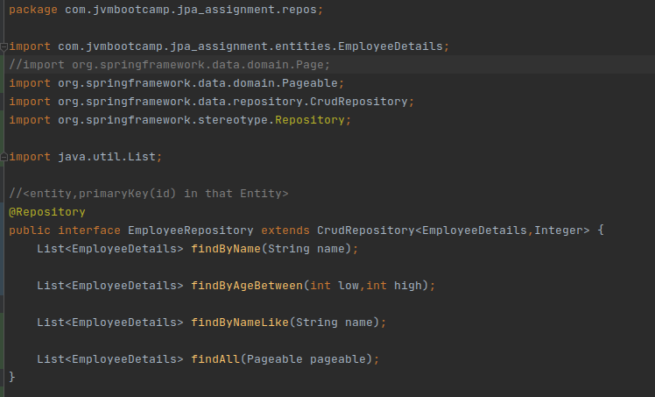

**(1) Create an Employee Entity which contains following fields**

**Name**

**Id**

**Age**

**Location**

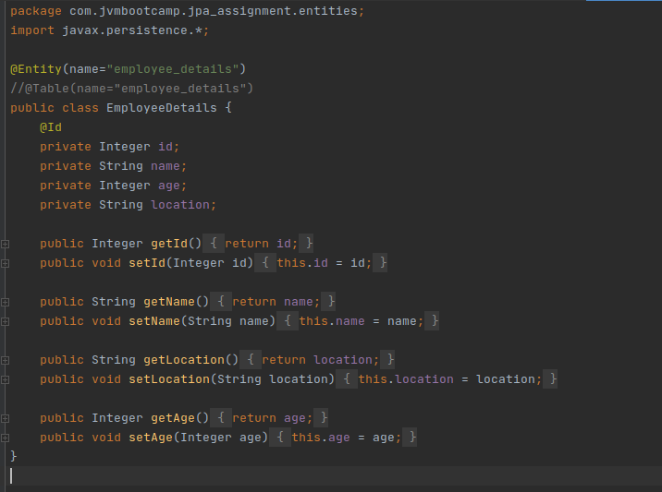

**-------------------------------------------------------------------------------------------------------------------------------**

**(2)Set up EmployeeRepository with Spring Data JPA.**

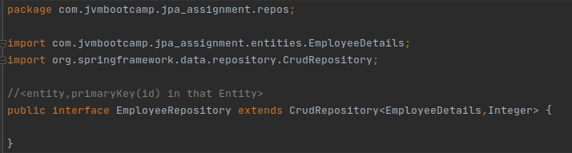

**-------------------------------------------------------------------------------------------------------------------------------**

**(3) Perform Create Operation on Entity using Spring Data JPA.**

**EmployeeController.java:**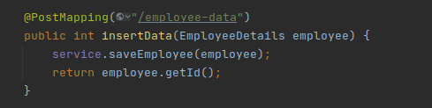

**EmployeeService.java:** 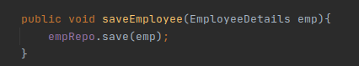

**Output: inserted the row:** [**http://localhost:8080/employee-data**](http://localhost:8080/employee-data) **(using post)**

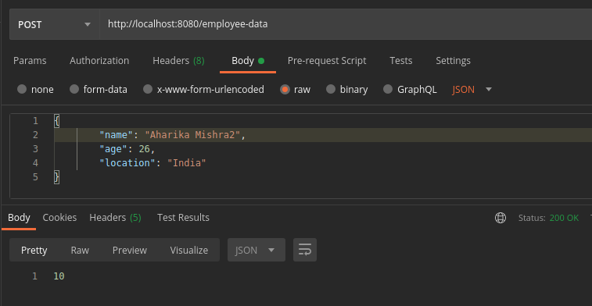

**Fetching the same using get** [**http://localhost:8080/employee-data/10**](http://localhost:8080/employee-data/10)

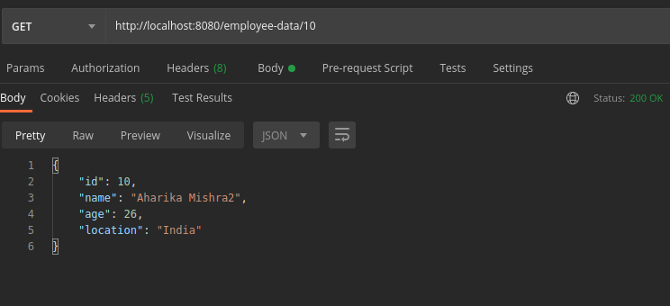

**-------------------------------------------------------------------------------------------------------------------------------**

**(4) Perform Update Operation on Entity using Spring Data JPA.**

**EmployeeController.java**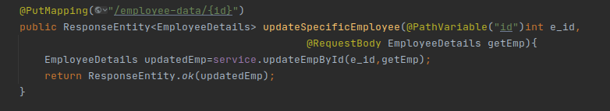

**EmployeeService.java**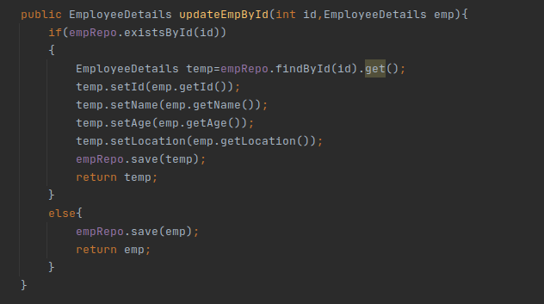

**Output: before updation-** [**http://localhost:8080/employee-data/9**](http://localhost:8080/employee-data/9) **(get)**

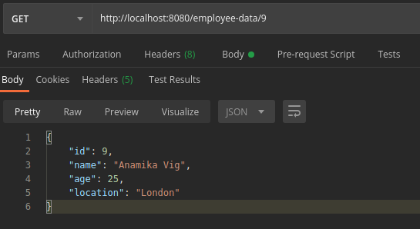

**Updating -----**

[**http://localhost:8080/employee-data/9**](http://localhost:8080/employee-data/9) **(using put)**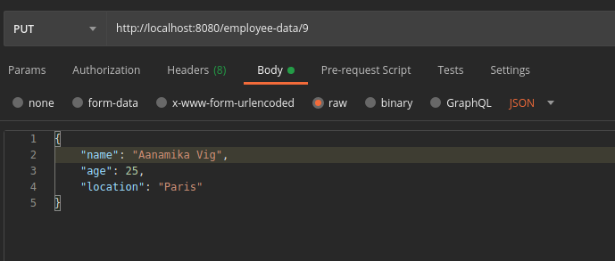

**After updation--** [**http://localhost:8080/employee-data/9**](http://localhost:8080/employee-data/9) **(using get)**

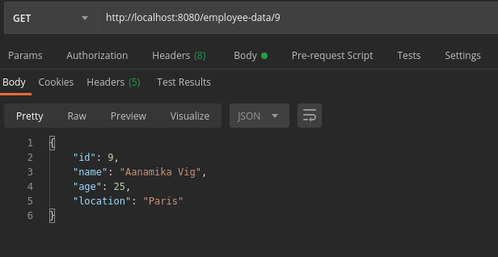

**-------------------------------------------------------------------------------------------------------------------------------**

**(5) Perform Delete Operation on Entity using Spring Data JPA.**

**EmployeeController.java**

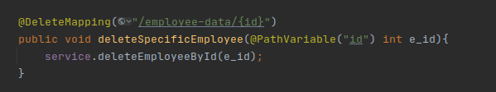

**EmployeeService.java**

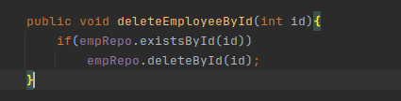

**Output: got the data-** [**http://localhost:8080/employee-data/8**](http://localhost:8080/employee-data/8)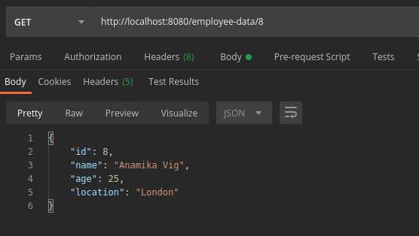

**Deleted the same-**

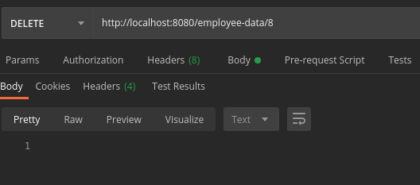

**Trying to retrieve the same after deletion:**

**Error:** [**http://localhost:8080/employee-data/8**](http://localhost:8080/employee-data/8) **(get)**

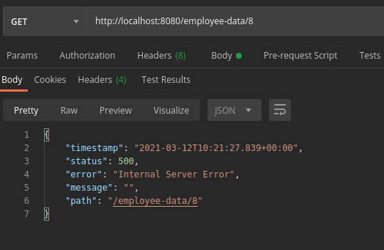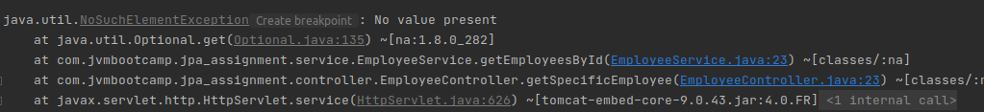

**-------------------------------------------------------------------------------------------------------------------------------**

**(6) Perform Read Operation on Entity using Spring Data JPA.**

**EmployeeController.java:** 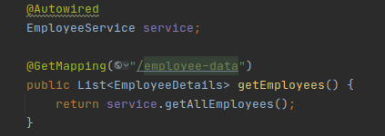

**EmployeeService.java:** 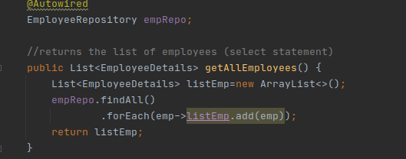

**Output:** [**http://localhost:8080/employee-data**](http://localhost:8080/employee-data)

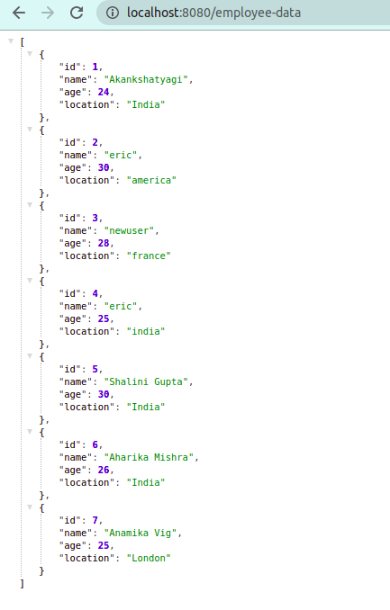

**-------------------------------------------------------------------------------------------------------------------------------**

**(7)Get the total count of the number of Employees.**

**EmployeeController.java:**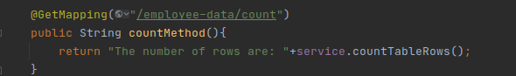

**EmployeeServices.java:**

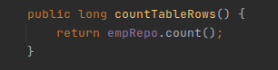

**Output:** [**http://localhost:8080/employee-data/count**](http://localhost:8080/employee-data/count)

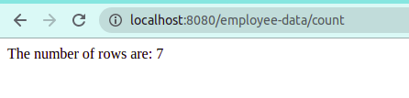

**-------------------------------------------------------------------------------------------------------------------------------**

**(7) Implement Pagination and Sorting on the bases of Employee Age.**

**EmployeeController.java**

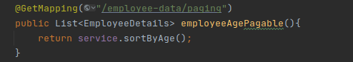

**EmployeeService.java**

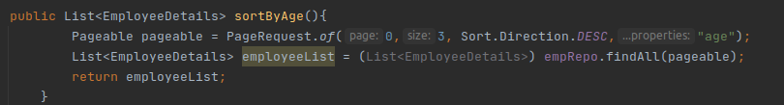

**Output:** [**http://localhost:8080/employee-data/paging**](http://localhost:8080/employee-data/paging)

**Ascending order-**

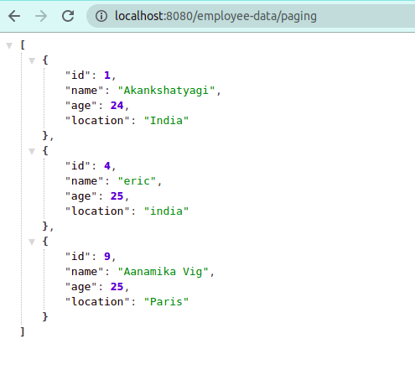

**Descending order:**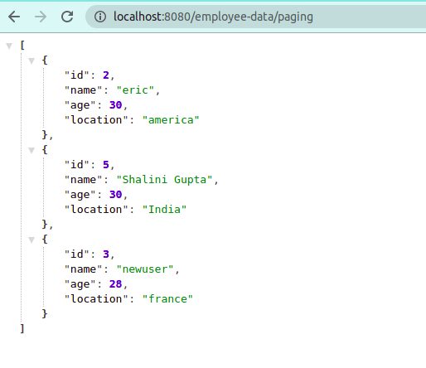

**-------------------------------------------------------------------------------------------------------------------------------**

**(8) Create and use finder to find Employee by Name.**

**EmployeeController.java:** 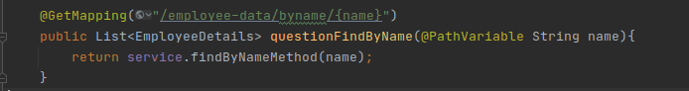

**EmployeeService.java**

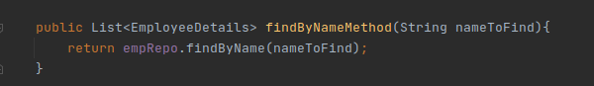

**Output:** [**http://localhost:8080/employee-data/byname/eric**](http://localhost:8080/employee-data/byname/eric)

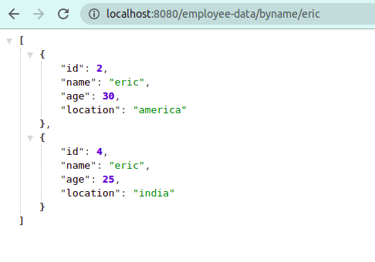

**-------------------------------------------------------------------------------------------------------------------------------**

**(9) Create and use finder to find Employees starting with A character.**

**EmployeeController.java**

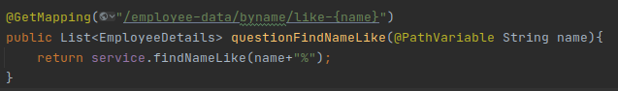

**Employeeservice.java**

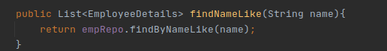

**Output:** [**http://localhost:8080/employee-data/byname/like-A**](http://localhost:8080/employee-data/byname/like-A)

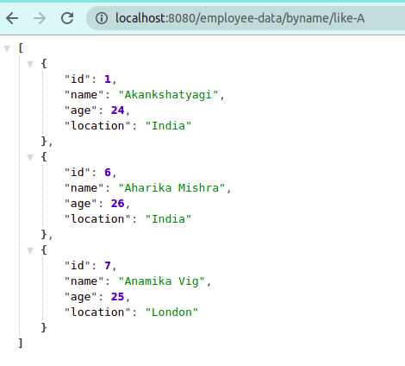

**-------------------------------------------------------------------------------------------------------------------------------**

**(10) Create and use finder to find Employees Between the age of 28 to 32.**

**EmployeeController.java**

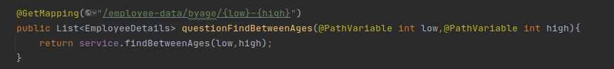

**EmployeeService.java**

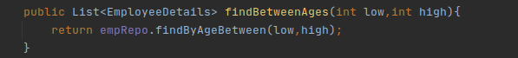

**Output:** [**http://localhost:8080/employee-data/byage/28-32**](http://localhost:8080/employee-data/byage/28-32)



